**Exercise 4-4 DCGAN**

Jirayu Petchhan, D10907801

We would like to compare the result of DCGAN and previous (linear) GANs result

hyper-parameter and criterion set up

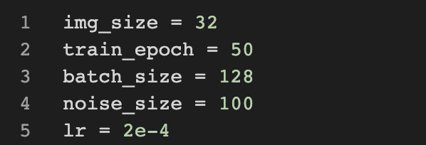



The result comparison between the present of DCGAN test and previous test of GANs

|  |  |  |
| --- | --- | --- |
| architecture | DCGAN | original GAN in style GAN (4-2) |
|  | DCGAN does not need the noise or latent seed added into the internal of the network to transfer style into the sample but the G model relies on the knowledge and weight update from discriminator. | The architecture needs to add the style with random latent noise seed which sums into the interval of synthetics networks *g* to generate the new style to our tested sample. |
| loss function | BCE loss (non-saturated loss): default | saturated loss (4-3) |
|  |  |  |
| WGAN-GP |  |  |
|  |  |  |

adding saturated loss for testing in loss function topic

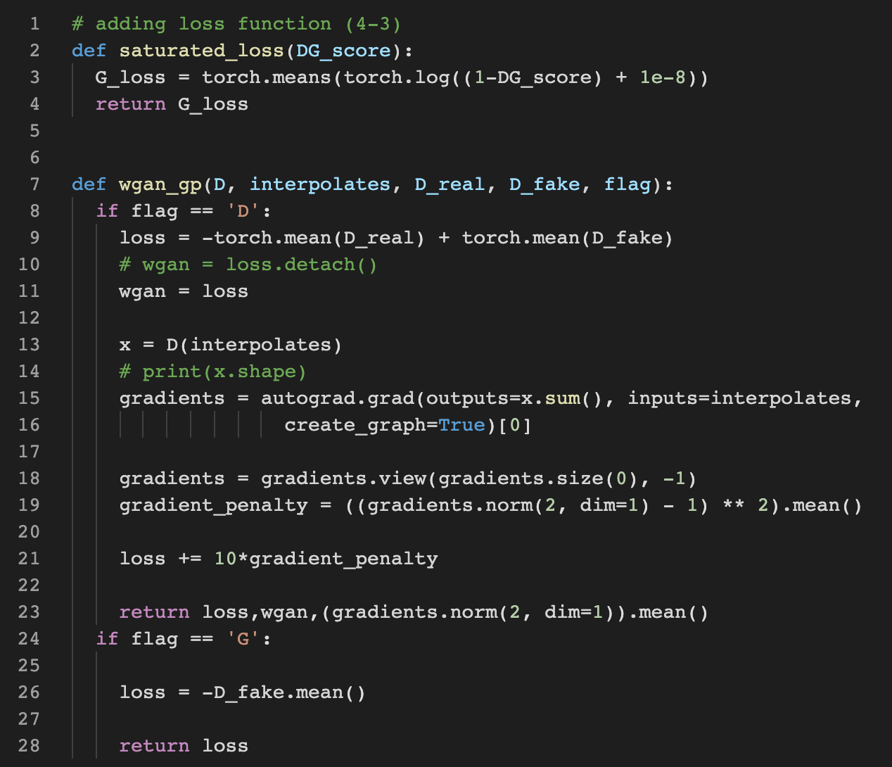

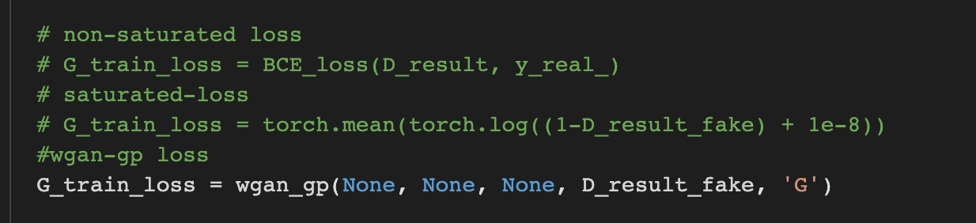

Conclusion

As we tested in DCGAN we got the result of wgan-gp loss is very oscilitation that other two losses (i.e., saturated and non-saturated loss). and the part of comparison of architecture, as we see that the DCGAN no required the noise vector to transfer the style in the summation interval of network different from StyleGANs.